**Lab 10 - CS 133N NAME: Amanda Akins**

Complete tutorial 6-1 and 6-2 in the text. Visual Studio start files are provided on Moodle. The textbook author has provided a video illustration of each tutorial at www.pearsonhigehered.com/gaddis. Feel free to view the video to help you do the tutorials, particularly if you miss class. Participate in the Lab questions forum if necessary. For all exercises at the end of the chapters in this course refer to the appropriate peer evaluation for more specific details about what will be required in your solution.

**Exercise 1 - Kilogram Conversion**

You did this problem in lab 4. However now you’re going to use methods for it.

Recall that the conversion rate of kilograms to pounds is given by: 1 kilogram = 2.20462 pounds

Create a method that returns the number of pounds given the number of kilograms.

Also recall that the conversion rate of pounds to ounces is given by: 1 pound = 16 ounces

Create a second method that returns the number of ounces given the number of pounds.

As in lab 8, your application should displays a table of kilograms from 10 to 25 along with the equivalent number of pounds and ounces. Use a Load Event handler to display that information. A start project is provided on Moodle. You can start with it or your previous solution. Your output should look like the following.

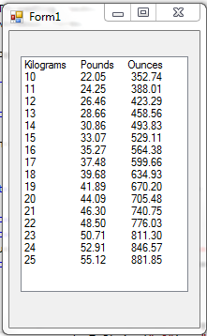

Upload a screen print of the program’s output and the source code for the form and its event handlers and methods to Moodle. There is no need to submit pseudocode for this exercise.

